Part A:

Question 1&2:

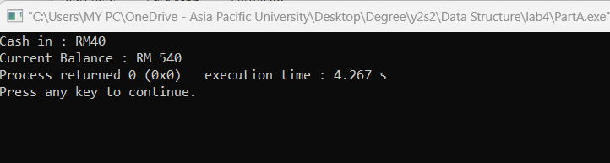

Question 3:

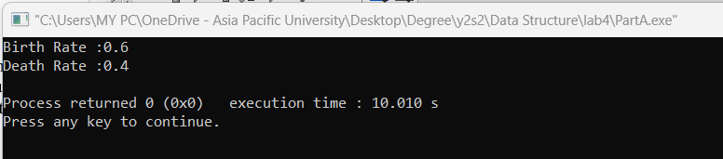

Question 4:

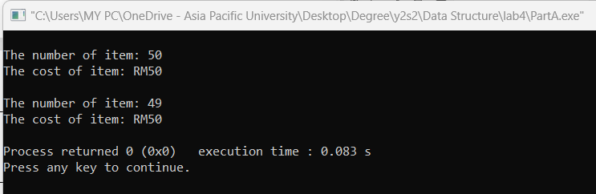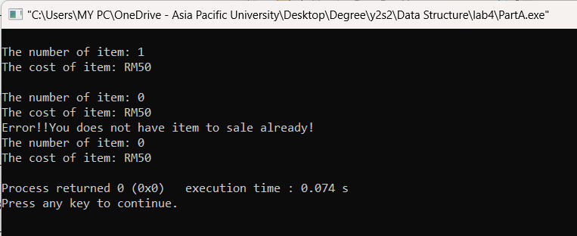

Part B

Question 1:

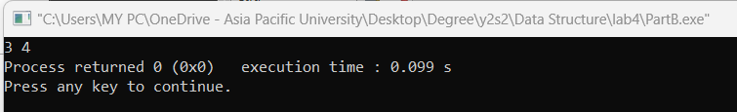

Part 2:

Question 1:

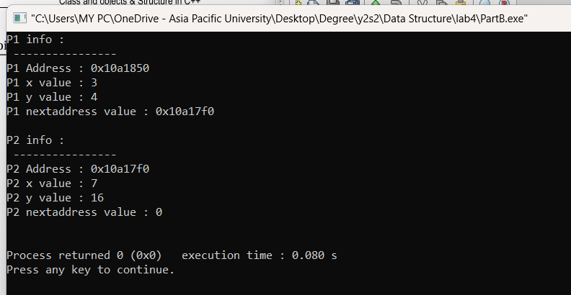

Question 2:

